

caAdapter v 4.0 - GME

Software Design Description

Version 0.4

02/07/2008

Document Change Record
Version Number | Date | Description
0.1 | 8/28/2007 | Initial document
0.2 | 8/30/2007 | Revised document
0.3 | 1/05/2008 | Detailed component content and add class diagrams
0.4 | 2/7/08 | Minor Edits + Notes from a meeting with the GME team (7-FEB-08)
0.5 | 2/7/9 | Edits from GME team meeting

TABLE OF CONTENTS
1. Introduction 3
2. System Architecture 3
2.1 Architecture Diagram 3
2.2 Subsystem Overview 3
2.2.1 GUI Subsystem 3
2.2.2 Transformation Service 3
2.2.3 Service component 3
2.2.4 Validation 3
2.2.5 Core Engine 3
3. COMPONENTS 3
3.1 Map Package 3
3.2 Metadata Package 3
3.3 NAMESPACE Package 3
3.4 Validation Package 3
4. DIAGRAMS 3
4.1 Collaboration Diagrams 3
4.2 CLASS DIAGRAMS 3
4.2.1 MAP PACKAGE 3
Figure 4.2.1 Class Diagram of Map Package 3
4.2.2 METADATA PACKAGE 3
Figuer 4.2.2 Class Diagram of Metadata Package 3
4.3 Sequence Diagrams 3
4.3.1 Loading Multiple XSDs 3
4.3.2 Editing Namespaces 3
Appendix A – acronym List 3

Introduction
The Software Design Description describes the design decisions, architectural design, and detailed design needed to implement the caAdapter’s GME Module. The System Design Description is used as the basis for implementing the software. It provides the acquirer visibility into the design and provides information needed for software support. This document also provides instruction for documenting the design of requirements.

System Architecture
Computer software architecture defines the structure of a software system, which includes software components, the externally visible properties of those components, and the relationships among them [L. Bass, P. Clements & R. Kazman, Software Architecture in Practice, Addison Wesley 1998]. Software architectures can provide a basis for the capture and subsequent reuse of design knowledge. Consequently, the goal of the software architecture is to allow the design of a system to take place at a higher level of abstraction capturing the most important top-level decisions about the overall structure and associated behavior of one or more software components.
This section provides a high-level overview of how the functionality and responsibilities of the system were partitioned and then assigned to subsystems or components. The main purpose is to gain a general understanding of how and why the system was decomposed, and how the individual parts work together to provide the desired functionality. Specifically, this section describes:
- The major responsibilities that the software must undertake (such as processing or messaging) and the various roles that the system (or portions of the system) must play.
- How the system is decomposed into its components/subsystems (identifying each top-level component/subsystem and the roles/responsibilities assigned to it).
- Information on the access/persistence mechanisms.
- How the higher-level components collaborate with each other in order to achieve the required results.

Architecture Diagram
An architecture diagram is used to illustrate an architecture design decision and the structure of inter-relating software components.

Java API
Web Service API
Java
Web Start
Mapping Tool Graphical User Interface
Core Engine
Metadata & Data Files
External
Services
Common Modules
Builder
Parser
Validater
Transformer
Data Viewer
Metadata Loader
HL7 v3 Mapping &
Transformation Service
HL7 v2 to v3
Conversion Service
Model
Mapping
Service
Regulatory
Data
Service
Other
Service
Components
Core
Service
Components
Data Format Specification Files
Source & Target Data Files

Figure 1 caAdapter High Level Architecture – Mapping Tool

Subsystem Overview
The goal of the caAdapter version v4.0 software system is to provide an open source solution that facilitates object to database, CSV to SDTM message, HL3 v2.x to v3.0 message transformation through a generic mapping solution. This section discusses each subsystem (as illustrated in Figure 1) as implemented in caAdapter.

GUI Subsystem
The Graphical User Interface (GUI) Subsystem presents a graphical interface that allows users to define, modify, export and import source and target specifications. The GUI enables end-users the ability to drag and drop between source and target file formats to realize a mapping file structure.

Transformation Service
The transformation service subsystem will read source data and according to the business rules defined in the core engine, generate target output files. The subsystem includes four modules:
- CSV-to-HL7 v3.0 transformation service
- Object Model-to-Data Model and Object Model-to-Object Model transformation service
- CSV-to-SDTM transformation service
- HL7 v2.x-to-v3.0 transformation service

This subsystem is designed to be “pluggable”, i.e. additional transformation services can be added without affecting other components of the system.

Service component
The Service component will parse the input file, output file, and generate Meta data for the core engine and transformation server for further process. The purpose of these components is to decouple the dependencies of the source and target file format with the core engine and transformation service.

Validation
The validation subsystem will perform different level of verification of the output from the transformation service, including:
- XML schema validation

- HL7 v2 schema validation
- HL7 v3 schema validation
- CSV schema validation
- Other customized validation

Core Engine
The Core Engine supplies mapping rules for the entire system.

COMPONENTS
The following snapshot illustrates the package structure and classes to be implemented for the caAdapter-GME integration effort:

Map Package
The map package consists of classes that contain information needed to establish a link between source object models and target models. The CumulativeMapping class contains a running list of validated mappings a user creates during the mapping process. When the mapping process is complete, the CumulativeMapping class will be the source to annotate the target xmi. The target xmi will be annotated with all mapping information such as source xds location, project mapping, package mapping, class mapping, attribute mapping and attribute mapping.
Note: No separated mapping file will be created.
Project Mapping Annotation:
The annotation process creates a new, or edits an existing, “GME_XMLNamespace” tag of <UML:Model name=”{modelName}”> element of the target object model. The annotation tag value defines the project name, context name, version number and package path of the namespace. There is one namespace per project at the model level. <UML:TaggedValue/> elements will be added to <UML:XMI.content/> tag to uniquely identify every class from any XSD. For each class, two tags will be added in pair .
<UML:Model name= "{modelName}" xmi.id ="{xxdd}” isRoot="false" isLeaf="false" isAbstract="false" visibility="public">
<UML:ModelElement.taggedValue>
<UML:TaggedValue tag="parent" value="{xxdd}" />
… …
<UML:TaggedValue tag=”GME_XMLNamespace” value= "gme://{projectName}.{contextName}/{version}/{packagePath}"/>
</UML:ModelElement.taggedVal>
… …
</UML:Package>
Package Mapping Annotation:
The annotation process also creates a new, or edits an existing, “GME_XMLNamespace” tag for the <UML:Package name=”{packageName}”> element of the target object model The annotation tag value defines the project name, context name, version number and package path of the namespace. There is one namespace per project at the model level. This will allow for each class to be uniquely identified.

<UML:Package name="{packageName}" xmi.id="{xxdd} " isRoot="false" isLeaf="false" isAbstract="false" visibility="public">
<UML:ModelElement.taggedValue>
<UML:TaggedValue tag="parent" value="{xxdd}"/>
… …
<UML:TaggedValue tag=”GME_XMLNamespace” value= "gme://{projectName}.{contextName}/{version}/{packagePath}"/>
</UML:ModelElement.taggedVal>
… …
</UML:Package>

Class Mapping Annotation:
The annotation process creates a new, or edits an existing, “GME_XMLElement” tag for the <UML:Class name=”{className}”> element of the target object model. The annotation tag value is set as the full path of the source object class with its project prefix. This will make each class uniquely identified.
<UML:Class name= "{className}" xmi.id= "{xxdd}" visibility= "public" namespace = "xxdd" isRoot= "false" isLeaf= "false" isAbstract= "false" isActive= "false">
<UML:ModelElement.taggedValue> <UML:TaggedValue tag= "ea_stype" value="Class"/>
<UML:TaggedValue tag="complexity" value="1"/>
… … <UML:TaggedValue tag="GME_XMLElement" value= "gme://com.example.bookstoreBook;ncicb:gov.nci.nih.caadapter.test.Book"/>
</UML:ModelElement.taggedValue>
</UML:Class>

Attribute Mapping Annotation:
The annotation process creates a new, or edits an existing, “GME_XMLLocReference” tag of <UML: Attribute name="{attributeName}"> element of the target object model. The annotation tag value is set as the full path of the source object class with its project prefix.
<UML:Attribute name="{attributeName}" changeable="none" visibility="private" ownerScope = "instance" targetScope="instance">
… … <UML:ModelElement.taggedValue>
<UML:TaggedValue tag="type" value="String"/>
<UML:TaggedValue tag="GME_XMLLocReference" value= " name (either ‘name‘ or “@name”) "/> <UML:TaggedValue tag="ea_localid" value="1549"/>
<UML:TaggedValue tag="styleex" value="volatile=0;"/>
</UML:ModelElement.taggedValue>
</UML:Attribute>
Association Mapping Annotation:
The annotation process creates a new, or edits an existing, “GME_SourceXMLLocRef” and a “GME_TargetXMLLocRef “ tag value for the <UML: Attribute> element of the target object model. Each tag value contains the references to rolenames and XML Elements for either the source or target XML locations.
<UML:Association>
<UML:Association.connection>
<UML:AssociationEnd visibility="public" multiplicity="1" aggregation= "none" isOrdered= "false" isNavigable="false" type="xxdd">
<UML:ModelElement.taggedValue>
… … </UML:ModelElement.taggedValue>
</UML:AssociationEnd>
<UML:AssociationEnd visibility="public" multiplicity= "0..*" name= "keyCollection" aggregation="none" isOrdered="false" isNavigable="true" type="xxdd">
<UML:ModelElement.taggedValue>
<UML:TaggedValue tag="containment" value= "xx"/>
<UML:TaggedValue tag="GME_SourceXMLLocRef" value= "gme:// {rolename}/{XMLElement of Class}"/>
<UML:TaggedValue tag="GME_TargetXMLLocRef" value= "gme:// {rolename}/{XMLElement of Class}”/>
</UML:ModelElement.taggedValue>

</UML:AssociationEnd>
</UML:Association.connection>

Metadata Package
The XSD Metadata Packages consists of classes representing the model metadata. The model metadata could be specified with an XMI format or an XSD format following GME standards. These classes allow for loading of multiple model metadata from different sources and setting up mapping from multiple source models to the same target model.

NAMESPACE Package
The Namespace Package allows the analyst to specify default namespaces for the Object Model. Also, it allows for editing of the namespaces when a mapping is loaded and successfully mapped to an XSD under the Link Properties panel.

Validation Package
As a user attempts to map objects/attributes in the source model to tables/columns in the target model, the validation package will determine if the attempted mapping is valid according to the specific GME mapping rules. The following mapping rule will be enforced:

- Allow map an association to association only if the objects referenced by the two association are mapped.

If the mapping is determined to be valid a line connecting the source element to the target element will be created in the UI

DIAGRAMS

Collaboration Diagrams

4.1.1 Loading and Saving XMI File
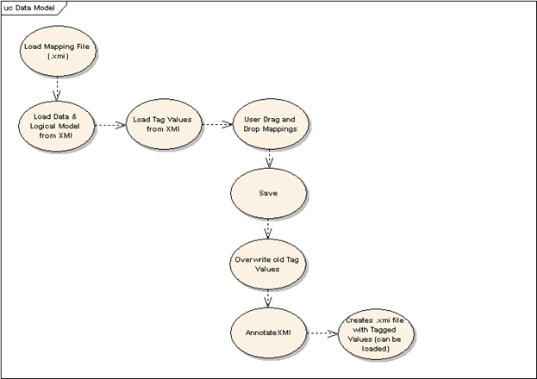

Figure 4.1.1 Loading and Saving an XMI file

CLASS DIAGRAMS

MAP PACKAGE
The following class diagram lists the major classes to build and parse a caAdapter mapping file. The MapBuilder processes mapping links generated with the mapping tool to annotate the target xmi. The MapParser reads the annotation information from a target xmi to create and display the mapping links.
class impl
BaseMapElementImpl
MapBuilderImpl
+
RCSID: String = "$Header: /shar...
+
build(OutputStream, Mapping) : void
BaseObjectImpl
Map
MapImpl
MapParserImpl
+
RCSID: String = "$Header: /shar...
+
getMapping() : Mapping
+
parse(String, FileReader) : ValidatorResults
Mapping
MappingImpl

Figure 4.2.1 Class Diagram of Map Package

METADATA PACKAGE
The following class diagram lists the major classes used to process an object model defined by either an xsd or an xmi file. These classes were defined by caAdapter common module to support the model mapping service as object-to-object, object-to-data, or csv-to-object mappings.

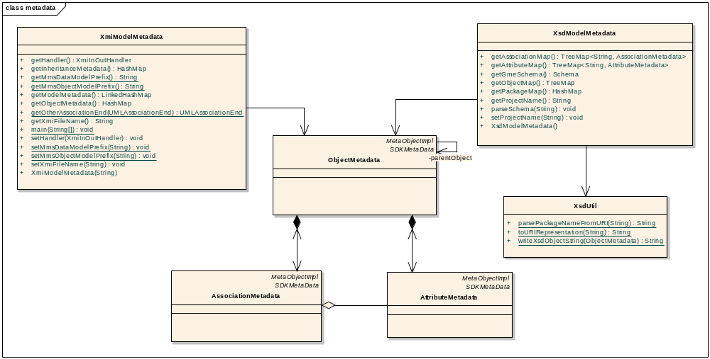

Figure 4.2.2 Class Diagram of Metadata Package

Sequence Diagrams

Loading Multiple XSDs

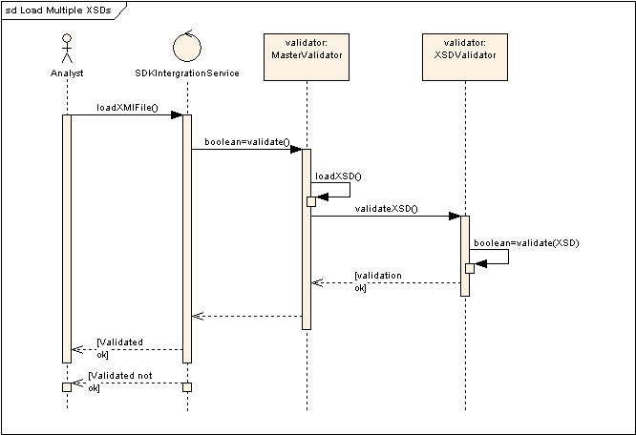

Figure 4.3.1 Sequence Diagram of Loading Multiple XSDs

Editing Namespaces
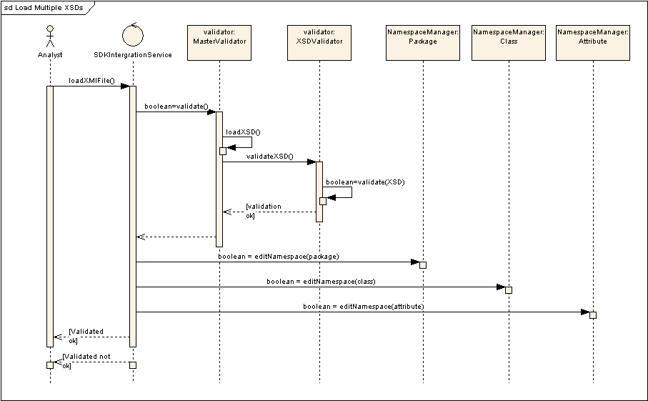

Figure 4.4.2 Sequence Diagram of Editing Namespaces

Appendix A – acronym List

Acronym | Description
CSV | Comma Separated Values
GME | Global Model Exchange
GUI | Graphical Users Interface
SDD | Software Design Description
SDTM | Study Data Tabulation Model
XMI | XML Metadata Interchange
XSD | XML Schema Definition

